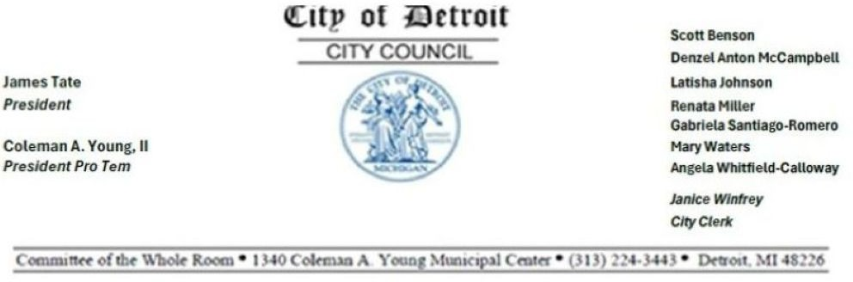
INTERNAL OPERATIONS STANDING COMMITTEE

To attend by phone only, call one of these numbers: +1 929 436 2866, +1 312 626 6799, +1 669 900 6833, +1
253 215 8782, +1 301 715 8592, +1 346 248 7799 - Enter Meeting ID: 85846903626

COUNCIL MEMBER ANGELA WHITFIELD-CALLOWAY, CHAIRPERSON COUNCIL MEMBER SCOTT BENSON, VICE CHAIRPERSON
COUNCIL MEMBER RENATA MILLER, MEMBER COUNCIL PRESIDENT JAMES TATE, EX-OFFICIO
Wednesday, January 7, 2026, 10:00 A.M. Glenn Kersey
Assistant City Council Committee Clerk

- ROLL CALL

- APPROVAL OF MINUTES

- CHAIR REMARKS

- PUBLIC COMMENT

- UNFINISHED BUSINESS

- NEW BUSINESS

BOARD OF ETHICS

  - Submitting report relative to
A resolution by the City of Detroit Board of Ethics admonishing Alvin Horhn, Deputy CFO/Assessor, Office of the Assessor. (REFERRED TO THE INTERNAL OPERATIONS

STANDING COMMITTEE ON 01/07/26)

  - Submitting report relative to
Second Request for Campaign Contributions and Expenditures Disclosures. (REFERRED TO THE INTERNAL OPERATIONS STANDING COMMITTEE ON 01/07/26)

  - Submitting report relative to
Letter regarding extension of interim suspension of Gayanga Co LLC and Brian McKinney (City of Detroit Office of Inspector General Notice of Extension of Interim Suspension of Gayanga Co LLC and Brian McKinney, and Any Companies in which They
Have Ownership or Financial Interest.) (REFERRED TO THE INTERNAL OPERATIONS STANDING COMMITTEE ON 01/07/26)
MISCELLANEOUS

  - Council Member Scott Benson
Submitting resolution Authorizing the Continuation of the Detroit City Council Wealth Generation Task Force. (REFERRED TO THE INTERNAL OPERATIONS STANDING COMMITTEE ON 01/07/26)

  - Council Member Scott Benson
Submitting resolution Authorizing the Continuation of the Detroit City Council Green Task Force. (REFERRED TO THE INTERNAL OPERATIONS STANDING COMMITTEE ON 01/07/26)

- MEMBER REPORTS

Page 2 of 2

