City of Detroit Demographic Data Portal (CD3P)
The City of Detroit’s Office of Digital Equity & Inclusion is focused on providing demographic data that can drive decision making citywide to bridge the digital divide. Using these data points to measure the impact we’re currently having, as well as outstanding needs in the community will ensure digital equity resources are being placed where they are most needed. This project will begin with local community outreach to organizations, nonprofits, to Fortune 100 companies interested in investing in the City of Detroit, with demographic data for the population we serve. Participants will have access to data identifying populations in need of devices, IT certification training, IT workforce internships and job placement. We understand measuring ROI and impact on the community we serve is the first step to closing the digital equality gap. Our goal is to ensure all data shared is securely managed in alignment with local and national data laws and requirements. That is why the Office of Digital Equity & Inclusion has partnered with Data Drive Detroit (D3). Through this partnership we will collect data from grassroots, local and national organizations, collecting demographics accurately representing the various demographic groups residing in the City of Detroit.
What Is the Timeline of This Project:
We will begin collecting data starting April 1, 2024, to December 20, 2024. Emails will be sent to all potential demographic data partners locally and nationally via email, starting March 22, 2024. The email will provide potential participants with a link to sign a “Data Sharing Agreement”, link to upload data and the option to sign up to be a part of the pilot. In January 2025 the Office of Digital Equity & Inclusion will launch a small focus group to test the open-source demographic data portal. From January 15, 2025, to March 15, 2025, working collaboratively with D3, will continue to make updates to “City of Detroit Demographic Open-Source Data Portal”.

What Type of Data Are We Collecting:
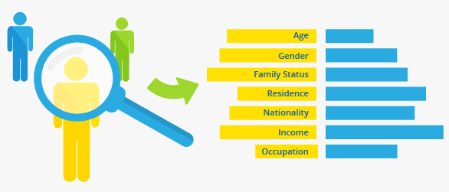
In 2023 the Office of Digital Equity & Inclusion was using population censuses data providing information on the size, composition, and spatial distribution of the population, including their demographic and socio-economic characteristics. We have identified gaps in the current demographic database currently being used to drive decision making.

Fully understanding the demand and need for digital equality in the City of Detroit requires developing a demographic database more closely aligned to the City of Detroit population. For example, data points clearly defining the number of residents with bachelor’s degrees and previous IT work experience to the number of IT companies in Detroit. Having a more complete understanding of the residents’ digital literacy gaps is key, whether it’s accessing fintech, telehealth, understanding how to do a google searches, to typing papers in Microsoft Word. Building this type of database requires working collaboratively with grassroot organizations, non-profits, corporations, to state agencies. Creating a “Shared Digital Equity Partnership” will give all participating agencies access to the open-source database. Our goal is to ensure the City of Detroit and stakeholders have access to accurate data points that mirror the urban demographic population we serve.
How Is This Project Being Executed:
The Office of Digital Equity & Inclusion has partnered with Data Drive Detroit (D3). Through this partnership we will collect data locally and nationally, helping to modernize our partner’s business reporting with automated, real-time data reporting, accurately representing the various demographic groups residing in the City of Detroit. Changing how we do reporting in Detroit will empower us to work with community stakeholders from a complete data set, paving the way for better decision-making.

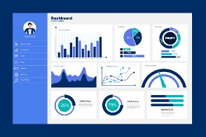
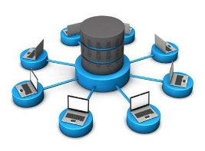

Empower Organizations with Self-service Analytics
Provide self-service access to BI and analytics while maintaining proper access to data.

Access Real-time Insights
Replace static spreadsheets with automated reporting fed by streams of fresh data.

Centralized Data
Have one source of data truth as the foundation for all your reports.

How Can You Use This Data to Drive Decision Making:
“Shared Data Partners” will receive access to an open-source data portal with multiple options to access this data. Each participant will be required to create a profile that allows us to manage data requests and support the local and national “Shared Data Partners”.
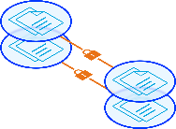
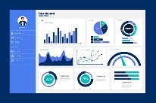
Embedded Analytics
Securely share data and insights outside your organization.
Visualizations & Dashboards
Create interactive, easy-to-use visualizations that support making data driven decisions.

Reporting & Self-Service Analytics
Modernize your reporting with real-time data that everyone can self-serve.
AI Data Management
Deliver actionable data experience that scale with an AI framework you can trust.

How Can Your Organization Sign-up for The Project:
The City of Detroit Office of Digital Equity & Inclusion and the D3 team would like to partner with your organization to create the first “City of Detroit Demographic Data Open-source Portal”. If you want more information about the project and how you can participate, Step 1 is completing the City of Detroit Demographic Data” form below. Step 2 is requesting the “Shared Data Agreement” and Step 3 is uploading your data to our secure database.
We look forward to working with your organization to transition from a highly siloed structure to one built upon interdepartmental collaboration and trust. The power of the “City of Detroit Demographic Data Portal (CD3P)” is showing stakeholders how working collaboratively to build this demographic data portal, is directly related to closing digital inequalities citywide. In partnership with D3 our team is focused on providing local and national stakeholders with the tools to do data analysis, queries, and create data resources they can share, that will drive decision making.

