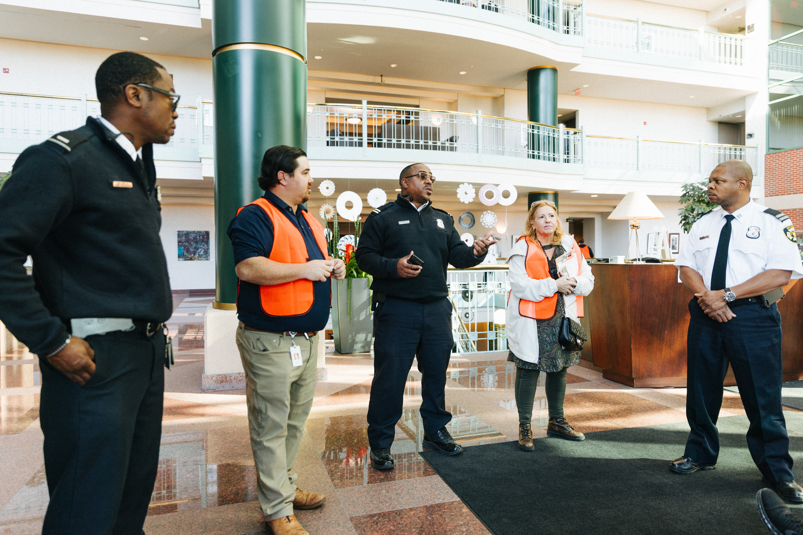**FIRE MARSHAL**

**The Detroit Fire Marshal Division** aims to provide the citizens and visitors of Detroit with the highest level of fire prevention methods and fire protection engineering using standards and codes set forth by the Detroit Fire Prevention and Protection Ordinance, NFPA and the Michigan Building Code. Our mission is rooted in fire prevention through inspections, code enforcement, plan review, investigation and public education, all delivered with outstanding customer service.

The Fire Marshal Division consists of two (2) sections:

**PLANS AND EXAMS**

**The Plans and Exams Section** of the Detroit Fire Department is responsible for analyzing all life safety and fire protection aspects of new construction, change of use and major renovation of commercial building projects. The section works closely with the Building Safety Engineering and Environmental Department (BSEED), Planning and Development Department (PDD), Detroit Water and Sewage (DWSD), Health Department and others to identify solutions to fire and life safety through planning and design.

The section approves projects to begin construction and modifications of design that comply with all national, state and city codes/standards. This is a critical step for citizens to obtain permits and construct and occupy their buildings.

**Services**

Services Include but are not limited to:

* Review of new and existing commercial, industrial, residential (3+ family) construction, additions and renovations
* Civil/Site plan layout for new development
* Pre-plan and pre-construction consultation
* Fire protection plan review (Fire alarms, fire suppression, monitoring, etc.)
* Code variance requests
* Municipal water tap approvals

**Plan a Visit**

Located in the Coleman A. Young Municipal Center at 2 Woodward, suite 411. Citizens can visit the office to handle all their permitting and project planning needs.

If you would like to learn more about submitting documents to our office, please review the “How to” video below.

[When ready to submit, click here to visit the application website.](https://aca3.accela.com/DETROIT/Default.aspx)

**[Video]**

**FIRE PREVENTION**

**The Fire Prevention Section** of the Detroit Fire Department is responsible for performing life safety inspections in all occupancies (assemblies, business, mercantile, industrial, apartments, etc.) to ensure compliance is met in accordance with the adopted codes as prescribed in the Detroit Fire Prevention and Protection Ordinance. Additionally, the Fire Prevention Section performs/witnesses acceptance testing of all required fire protection and life safety systems that are installed in new and existing buildings.

**Units**

* Public Assemblies – 313.596.2932
* Public Instruction – 313.596.2968
* General Assignments/New Construction – 313.596.2954
* Hazardous Materials – 313.596.2931
* Institutions – 313.596.8892
* Court Enforcement – 313.596.2970

Every business type is required to obtain an annual fire permit as per the Detroit Fire Prevention and Protection Code. The Fire Prevention Section is committed to ensuring the safety of citizens and visitors of Detroit through public education, community engagement, life safety inspections and code enforcement.

**Services**

Additional services provided by this section include:

* Fire sweeps
* Fire watch/training
* Code review/variances
* Consultations
* Hazardous materials escorts
* Certificate of fitness testing
* Evacuation plans/drills

**NFPA RESOURCES**

Committed to community risk prevention, the Detroit Fire Marshal Division heavily encourages education regarding fire safety.

[Click here to access informational materials provided by the **National Fire Prevention Association** and learn vital safety tips.](https://www.nfpa.org/education-and-research/home-fire-safety/safety-tip-sheets#aq=%40culture%3D%22en%22&cq=%40tagtype%3D%3D(%22Safety%20tip%20sheets%22)%20%20&numberOfResults=12&sortCriteria=%40title%20ascending)

**BUSINESS SELF RE-INSPECTION**

The Detroit Fire Department’s Small Business Self Re-Inspection program offers small business owners the opportunity to address and clear minor code violations independently. The program is open to low-hazard small business under 2,000 square feet void of complex fire safety systems, and provides tools needed to conduct inspections and remain in compliance with fire safety regulations.

[Click here to learn more.](https://detroitmi.gov/news/detroit-fire-department-launches-self-re-inspection-program-assist-small-business-owners)

**[CONTACT BOX; *CENTER OF PAGE; TEXT LEFT JUSTIFIED*]**

Fire Marshal  
Marhsal Don Thomas  
313.596.2954, Fax: 313.596.2978  
dfdfmdgeneral@detroitmi.gov