FOR RELEASE: April 7, 2022
MEDIA CONTACTS: Barb Roethler: 313 400-7107
Barbara.Roethler@detroitmi.gov
Margaret Carroll: 313-300-3152
Margaret.Carroll@detroitmi.gov

(EDITOR’S NOTE: Mark Kumpf, Director of Animal Care is available for media interviews all day)

DETROIT ANIMAL CARE CELEBRATES OPENING DAY WITH FREE ADOPTIONS THROUGH MONDAY 4/11

- Adoption and licensing fees waived through 4/11, all animals are neutered, microchipped and come with free goodie bags

Detroit Animal Care is celebrating Opening Day with free adoptions for all cats and dogs. All adoption and licensing fees are waived today through Monday, April 11th. All animals are fully vaccinated, micro-chipped and neutered. Every animal comes with a goodie bag of treats.

“We are celebrating Opening Day and Kitten Season,” said Mark Kumpf, Director of Animal Care. “April is traditionally when we experience a higher volume intake of kittens. We obtained a state-of-the-art incubator to give our youngest kitties a good chance to survive in a shelter and give our team time to locate a foster who is willing to bottle feed. When given an opportunity to save more lives, we always choose to do so.” Kumpf reported DAC is already taking in neonate kittens (eyes closed, days old).

Listings of pets available to adopt and foster are updated daily throughout the week on The Detroit Health Department’s Instagram https://www.instagram.com/dethealth/ and Facebook page https://www.facebook.com/DetHealth.

Detroiters are always welcome to visit Detroit Animal Care, which is open to the public for adoptions daily from 10:30 AM – 3:30 PM. Detroit Animal Care is located at 7401 Chrysler Drive, Detroit.

Miguel Cabrera, male, 1 yr, 1 month. Triple Crown Winner! Super docile and gentle, nonreactive to other animals, ready to slide in to your home base!
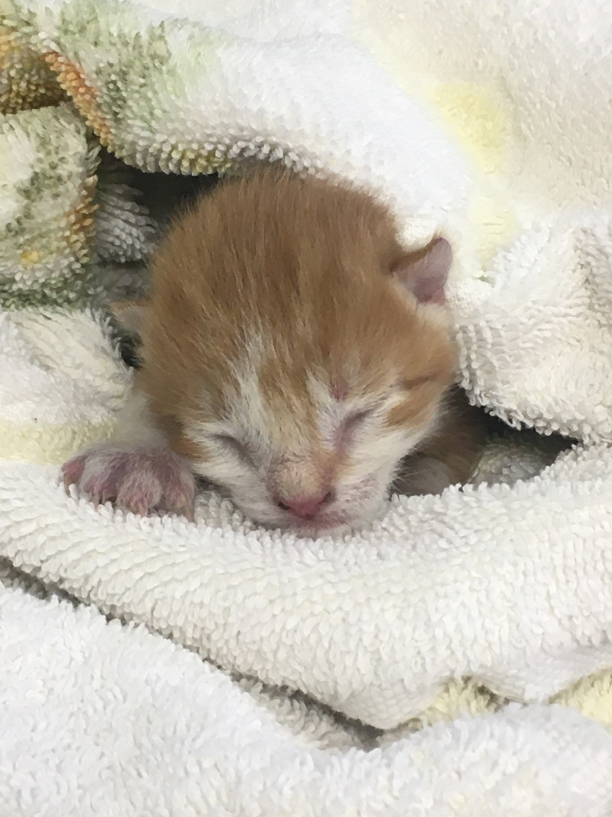 “Sweet Lou” Whitaker, one of many young kittens on the roster! “Sweet Lou” will be ready for placement in approximately six weeks

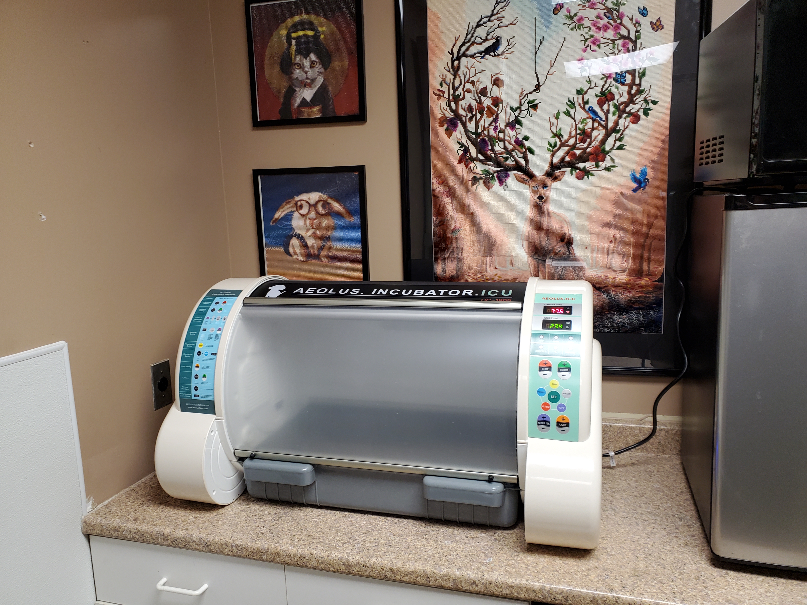
DAC’s new addition is saving lives, providing needed warmth until neonate kittens can be placed in homes with people who are able to bottle-feed until they mature at approximately xx weeks

