January 10, 2020

Mr. Paul Owens
District Supervisor
Warren District Office
Remediation and Redevelopment Division
SUBJECT: Compliance Communication: Notice of Section 20107a of Part 201 Obligations
Former Revere Copper and Brass
5851 West Jefferson, Wayne County, Michigan
EGLE Site ID No. 82000136 (the “Site”)

Dear Mr. Owens:
Detroit Bulk Storage, Inc., (“DBS”) has received your December 11, 2019, compliance communication regarding the above-referenced Site. We take this matter very seriously.
DBS was a lessor at the Site. It was not fully aware of the Site’s status under Part 201. Please accept this correspondence as our response and please advise if further information is required from us. DBS is working with the Site’s owner to address the recent event at the Site that triggered your communication. Since DBS does not have total Site control, it is proceeding cautiously, but as diligently as possible. We met with members of your office and the USEPA yesterday.
Since the collapse of the dock located at 5851 West Jefferson, we have had multiple discussions with representatives of EGLE, USEPA, and the Army Corps of Engineers. We have also had recent discussions with the owner of property, Revere Dock, LLC (Revere) and its experts to ascertain potential risk pathways and to understand their proposed Site mitigation plans and due care strategies so as to minimize confusion and interference possibilities. Further, during our t meeting on January 9, 2019, which included State and Federal representatives, Revere’s experts from PM Environmental and G2 Environmental, Revere reported that there is no imminent or short-term threat of dermal contact exposure for the public.
Moreover, Revere has already installed a 5’ silt curtain and plans to install a larger 20’ silt curtain. Under Revere’s direction, we plan to extend the silt curtain barrier to 100% surround the collapsed area, extend to the shoreline and to the stone wall on the north end of the property. Also, as we have been asked to do, we will install a clean stone berm between the pooled water area and the shoreline. Revere has indicated they will also submit a letter to all stakeholders today outlining interim actions as well as a timeline for subsequent responses.

We are available anytime to discuss this matter. Please do not hesitate to call me directly at ph. (313) 999-9015.
Sincerely,

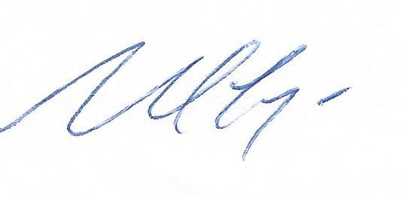
Noel Frye

